Dr. A. Q. Khan Institute of Computer Science & Information Technology



Lab no. 06
Artificial Intelligence (Lab)
Submitted to:
MAM HAJRA
Submitted by:
Tehzeeb (232101006)
Department:
BSCE-7.
Date:
Oct 12th, 2026

Coding/logic | Response | Data processing & visualization | Accuracy | Outcome/Result
04 | 04 | 04 | 04 | 04
LINK: https://github.com/Tehzeb/AI-LAB/tree/main/AI%20LAB5

====================================================================
LAB 6: LOGISTIC REGRESSION — BREAST CANCER CLASSIFICATION & CDSS
Course: Artificial Intelligence Lab (CE-7)
====================================================================
QUESTION:01 Mapping: CLO-02 | PLO-02, PLO-05 | WK4, WK6 | EC3, EC5 | SDG 9
[Step 1] Successfully loaded dataset from:
C:\CE\CE-7\GitHub\AI LAB\AI LAB 6\data.csv
Initial Dataset Shape: (569, 33)

[Step 3] Columns with Missing (NaN) Values:
Unnamed: 32 569
dtype: int64

[Step 2] Cleaned Features Shape (X): (569, 30) | Target Shape (y): (569,)
Target Mapping: {'B': np.int64(0), 'M': np.int64(1)}

>>> Generating Figure 1: Visual Audit for Steps 1, 2 & 3...
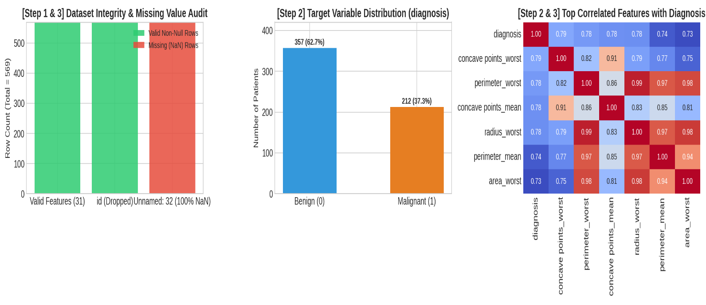

[Step 4] Training Samples: 455 | Testing Samples: 114
[Step 5 & 6] Model Trained! First 10 Predictions: [0 1 0 1 1 0 1 0 0 0]
First 10 Actual Test Labels: [0 1 0 1 0 0 1 0 0 0]
>>> Generating Figure 2: Visual Analytics for Steps 4, 5 & 6...
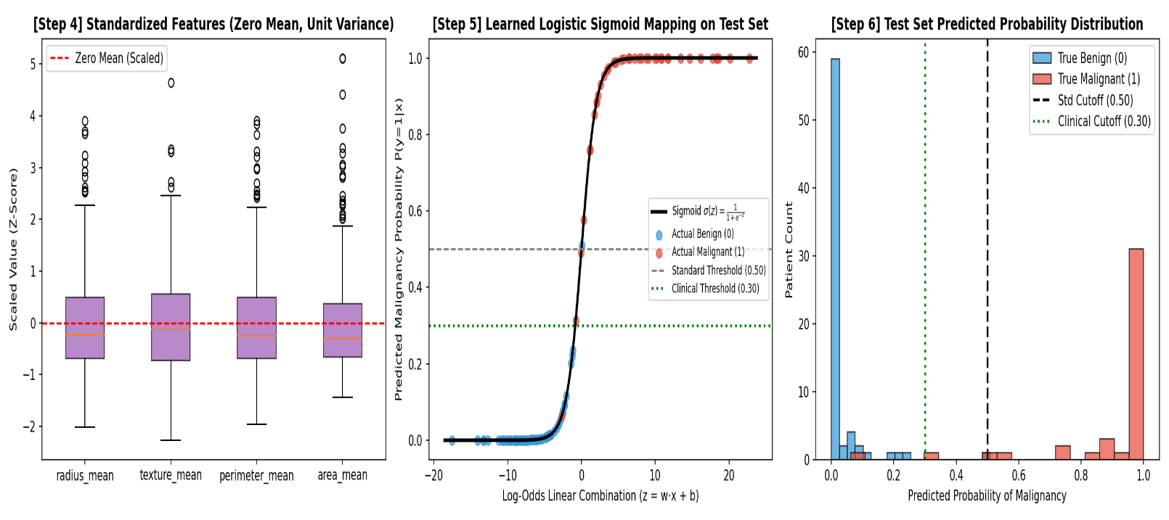

=========================================================================
[Step 7] MODEL PERFORMANCE & INNOVATIVE CLINICAL BENCHMARKS
=========================================================================
Accuracy (Test Set) : 0.9649 (96.49%)
5-Fold Stratified CV Acc : 0.9737 (+/- 1.66%)
Precision : 0.9750 (97.50%)
Recall (Standard Thr=0.50): 0.9286 (92.86%) | Missed Cancers (FN): 3
Recall (Clinical Thr=0.30): 0.9762 (97.62%) | Missed Cancers (FN): 1
F1-Score : 0.9512 (95.12%)
ROC-AUC Score : 0.9960 (99.60%)

Detailed Classification Report:
precision recall f1-score support

Benign (0) 0.96 0.99 0.97 72
Malignant (1) 0.97 0.93 0.95 42

accuracy 0.96 114
macro avg 0.97 0.96 0.96 114
weighted avg 0.97 0.96 0.96 114

--- INNOVATION: AUTOMATED CLINICAL DECISION SUPPORT SYSTEM (CDSS) TRIAGE LOG ---
Patient #000 | Malignancy Prob: 0.04% | Actual: Benign | Triage: LOW RISK (Routine Annual Screening)
Patient #001 | Malignancy Prob: 100.00% | Actual: Malignant | Triage: HIGH RISK (Immediate Biopsy & Oncology Referral)
Patient #002 | Malignancy Prob: 4.26% | Actual: Benign | Triage: LOW RISK (Routine Annual Screening)
Patient #004 | Malignancy Prob: 50.92% | Actual: Benign | Triage: MODERATE RISK (Secondary Diagnostic Imaging)
Patient #018 | Malignancy Prob: 22.18% | Actual: Benign | Triage: LOW RISK (Routine Annual Screening)

>>> Generating Figure 3: Evaluation & Innovation Dashboard (Step 7 & 8)...

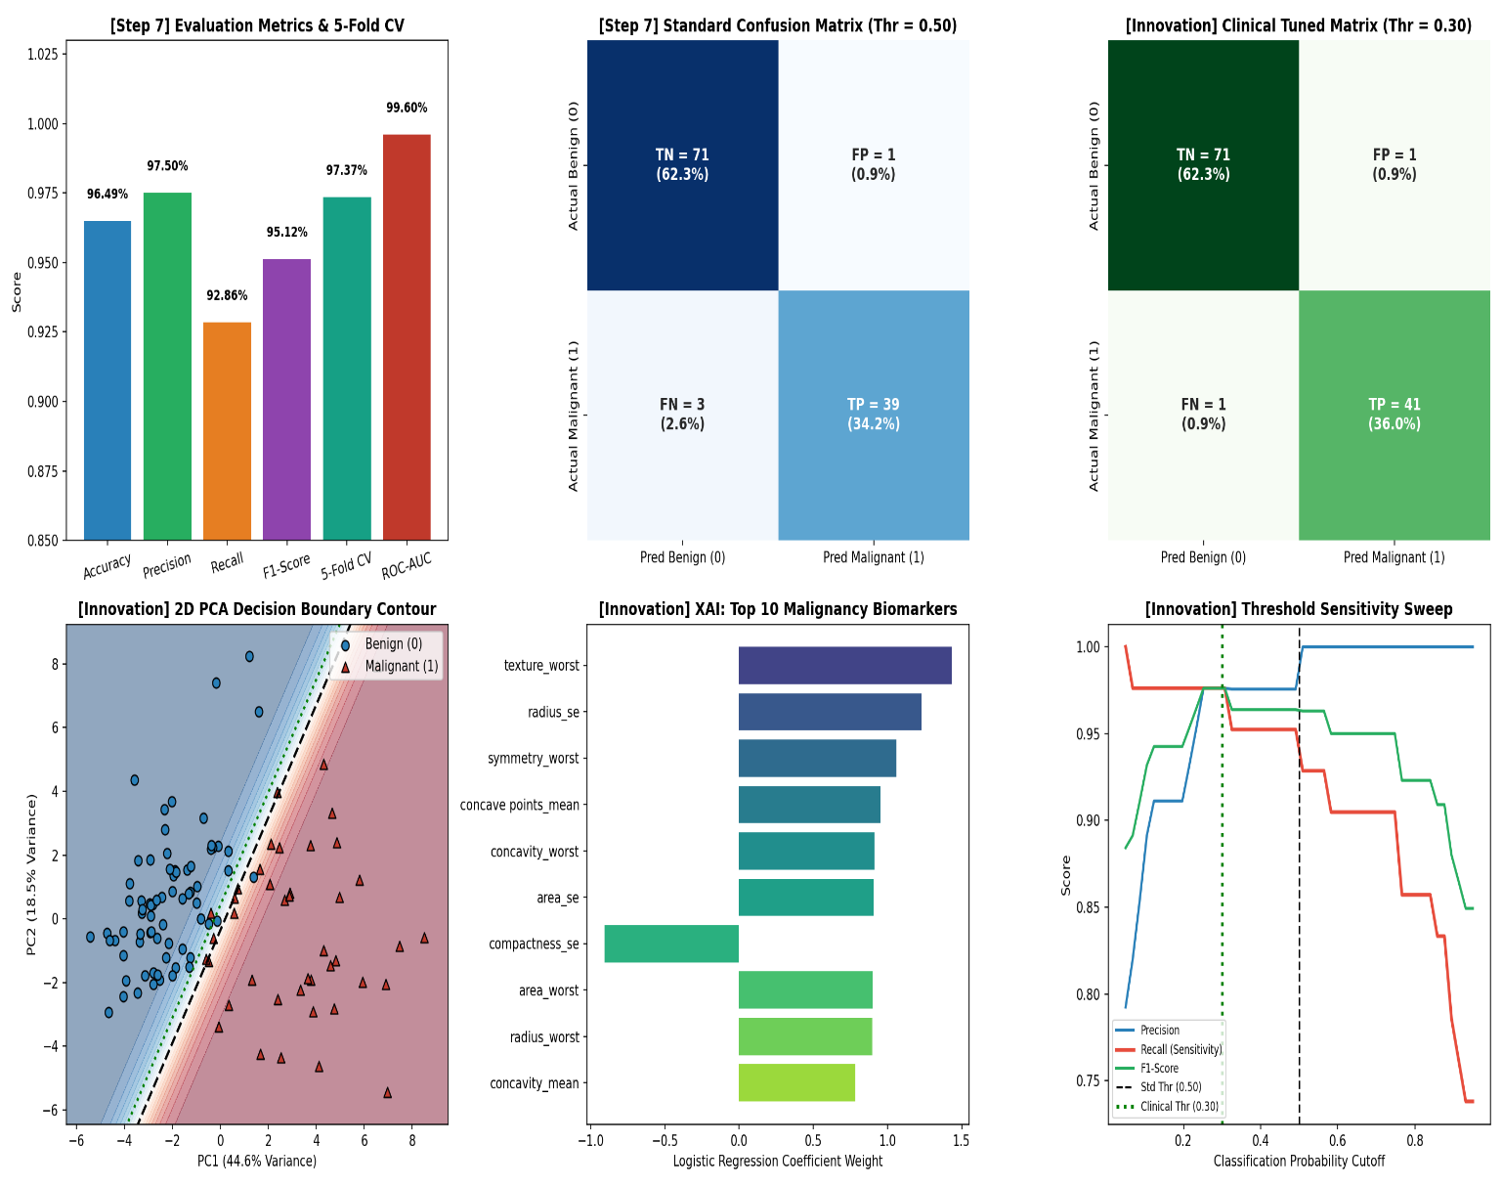

====================================================================
[Step 8] WHY LOGISTIC REGRESSION IS SUITABLE FOR THIS BINARY CLASSIFICATION PROBLEM
====================================================================
1. Binary Outcome Alignment: Classifies tumors strictly into Benign (0) or Malignant (1).
2. Probabilistic Sigmoid Mapping: Outputs calibrated probabilities [0, 1] (shown in Fig 2B), enabling clinical threshold tuning (0.50 -> 0.30) to raise Recall from 92.86% to 97.62%.
3. Explainable AI (White-Box): Feature weights directly reveal key cellular biomarkers (Fig 3E).
4. High Linear Separability: As proven by the 2D PCA boundary (Fig 3D) and 5-Fold CV (97.37%), the standardized morphological features are linearly separable with a 0.9960 ROC-AUC.
====================================================================
PART 1: CORE TASK REQUIREMENTS (STEPS 1 TO 8)
KNN IRIS FLOWER CLASSIFICATION
====================================================================
[Step 1] Dataset Successfully Loaded From: C:\CE\CE-7\GitHub\AI LAB\AI LAB 6\Iris.csv
Initial Dataset Shape: (150, 5)

First 5 Rows of Dataset:
sepal_length sepal_width petal_length petal_width species
0 5.1 3.5 1.4 0.2 Iris-setosa
1 4.9 3.0 1.4 0.2 Iris-setosa
2 4.7 3.2 1.3 0.2 Iris-setosa
3 4.6 3.1 1.5 0.2 Iris-setosa
4 5.0 3.6 1.4 0.2 Iris-setosa

------------------------------------------------------------------------------------------
[Step 2 & 3] Feature Identification, EDA & Preprocessing Check
------------------------------------------------------------------------------------------
Input Features (X): ['sepal_length', 'sepal_width', 'petal_length', 'petal_width']
Feature Shape: (150, 4)
Target Variable: species
Encoded Classes:
Setosa = 0
Versicolor = 1
Virginica = 2

Missing Values Count: 0

Class Balance Check:
Class 0 (Setosa): 50 samples (33.3%)
Class 1 (Versicolor): 50 samples (33.3%)
Class 2 (Virginica): 50 samples (33.3%)

Summary Statistics of Raw Features:
count mean std min 50% max
sepal_length 150.0 5.84 0.83 4.3 5.80 7.9
sepal_width 150.0 3.05 0.43 2.0 3.00 4.4
petal_length 150.0 3.76 1.76 1.0 4.35 6.9
petal_width 150.0 1.20 0.76 0.1 1.30 2.5
Why Feature Scaling Is Required:
KNN calculates distances between samples. Features with larger numerical ranges can dominate the Euclidean distance calculation. StandardScaler transforms features to a comparable scale.
------------------------------------------------------------------------------------------
[Step 4] Stratified Train-Test Split (80/20) & Feature Scaling ------------------------------------------------------------------------------------------
Training Samples: 120
Testing Samples : 30

Generating Figure 1: EDA and Feature Scaling...
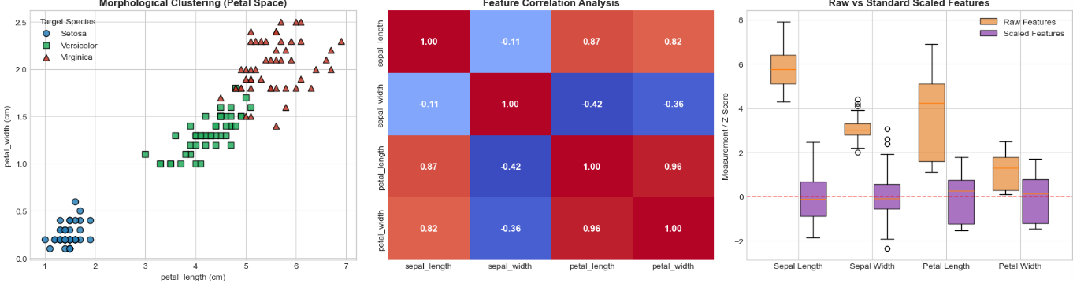
====================================================================================
[Step 5, 6 & 7] KNN MODEL EVALUATION
Comparison of K = 3, K = 5 and K = 7
====================================================================================

Model Comparison:
K Value Test Accuracy Correct Predictions Weighted Precision Weighted Recall Weighted F1-Score Misclassified Flowers
K = 3 93.33% 28/30 94.44% 93.33% 93.27% 2
K = 5 93.33% 28/30 94.44% 93.33% 93.27% 2
K = 7 96.67% 29/30 96.97% 96.67% 96.66% 1

Best K Based on Test Accuracy: K = 7
Best Test Accuracy: 96.67%

Detailed Classification Report for K = 7:
precision recall f1-score support

Setosa 1.00 1.00 1.00 10
Versicolor 0.91 1.00 0.95 10
Virginica 1.00 0.90 0.95 10

accuracy 0.97 30
macro avg 0.97 0.97 0.97 30
weighted avg 0.97 0.97 0.97 30

Generating Figure 2: Confusion Matrices...
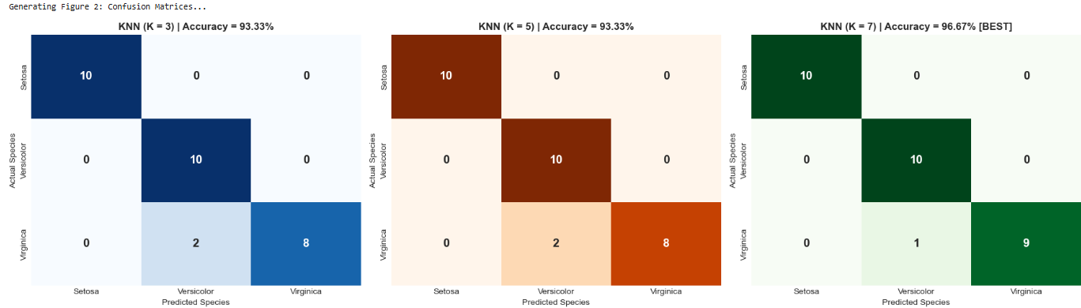

====================================================================================
[Step 8] BEST K IDENTIFICATION & KNN THEORY
====================================================================================

1. Best K on the Selected Test Set:
K = 7 achieved the highest test accuracy of 96.67%.
It correctly classified 29 out of 30 flowers.

2. Why KNN Classifies Using Nearest Neighbors:
KNN is a non-parametric and instance-based learning algorithm.
It assumes that samples with similar characteristics are located
close to each other in the feature space.

3. Euclidean Distance Formula:
d(xq, xi) = sqrt(sum((xq,j - xi,j)^2))

4. Majority Voting:
KNN finds the K closest training samples and assigns the test
sample to the class receiving the highest number of votes.

************************************************************************************
PART 2: ADVANCED ENGINEERING INNOVATIONS
************************************************************************************

1. Hyperparameter Sensitivity Sweep (K = 1 to 25)
2. Uniform vs Distance-Weighted KNN
3. 5-Fold Stratified Cross-Validation
4. PCA Decision Boundaries
5. Multi-Metric Distance Benchmark
6. K = 7 Nearest Neighbor Audit

[Innovation 1] Results:
Uniform KNN (K = 7) Test Accuracy: 96.67%
Distance-Weighted KNN (K = 7) Test Accuracy: 100.00%
Peak 5-Fold CV Accuracy: 97.33% at K = 6

------------------------------------------------------------------------------------
[Innovation 4] K = 7 NEAREST-NEIGHBOR AUDIT
------------------------------------------------------------------------------------
Test Flower #00 | True: Setosa | Predicted: Setosa | Confidence: 100.0% | Mean Distance: 0.408 | 7-NN Votes: {'Setosa': 7}
Test Flower #05 | True: Versicolor | Predicted: Versicolor | Confidence: 71.4% | Mean Distance: 0.651 | 7-NN Votes: {'Versicolor': 5, 'Virginica': 2}
Test Flower #12 | True: Virginica | Predicted: Virginica | Confidence: 100.0% | Mean Distance: 0.529 | 7-NN Votes: {'Virginica': 7}
Test Flower #23 | True: Virginica | Predicted: Virginica | Confidence: 57.1% | Mean Distance: 0.667 | 7-NN Votes: {'Versicolor': 3, 'Virginica': 4}
Test Flower #25 | True: Versicolor | Predicted: Versicolor | Confidence: 71.4% | Mean Distance: 0.536 | 7-NN Votes: {'Versicolor': 5, 'Virginica': 2}

Generating Figure 3: Advanced Engineering Innovations...

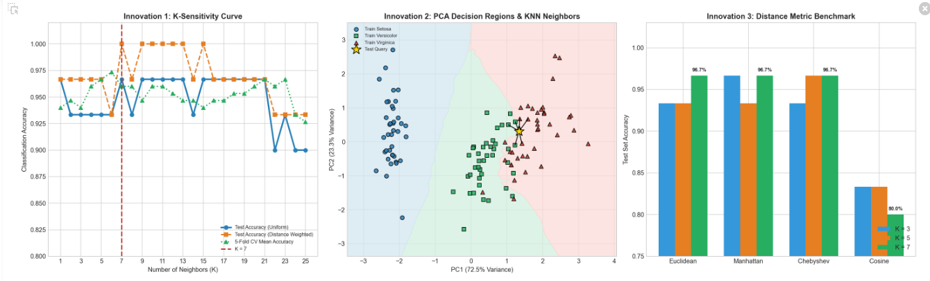
====================================================================
FINAL LAB SUMMARY
====================================================================
Dataset Used : C:\CE\CE-7\GitHub\AI LAB\AI LAB 6\Iris.csv
Total Samples : 150
Training Samples : 120
Testing Samples : 30
Best K from K=3,5,7 : K = 7
Best Test Accuracy : 96.67%
Best 5-Fold CV K : K = 6
Best 5-Fold CV Accuracy : 97.33%

All KNN classification requirements and advanced analyses completed successfully.

====================================================================
(Q3): SUPPORT VECTOR MACHINE (SVM) — BREAST CANCER CLASSIFICATION
[CLO- 02, PLO-03, P4 (Execute) (WK5, EC4, and SDG 11) Rubric (Syntax, Logic, Completeness, (Outcome) Points (12)]
====================================================================
[Step 1] Successfully loaded dataset from: C:\CE\CE-7\GitHub\AI LAB\AI LAB 6\data.csv
[Step 2] Input Features Shape (X): (569, 30) | Binary Target Shape (y): (569,)
Target Mapping: {'B': np.int64(0), 'M': np.int64(1)}
[Step 3] Stratified Split (Same as Q1) -> Train: 455 | Test: 114
[Step 4] Applied StandardScaler (Zero Mean μ=0, Unit Variance σ=1).
[Step 5 & 6] SVM (RBF) Trained! Total Support Vectors learned: 107/455
First 10 Test Predictions: [0 1 0 0 0 0 1 0 0 0]
First 10 Actual Labels: [0 1 0 1 0 0 1 0 0 0]
>>> Generating Figure 1: Feature Scale Audit & Empirical Impact of Scaling on SVM...
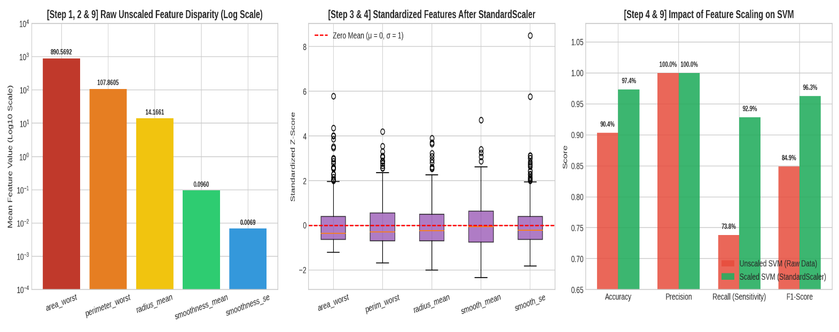
>>> Generating Figure 2: SVM Decision Boundary, Support Vectors & Multi-Kernel Benchmark...
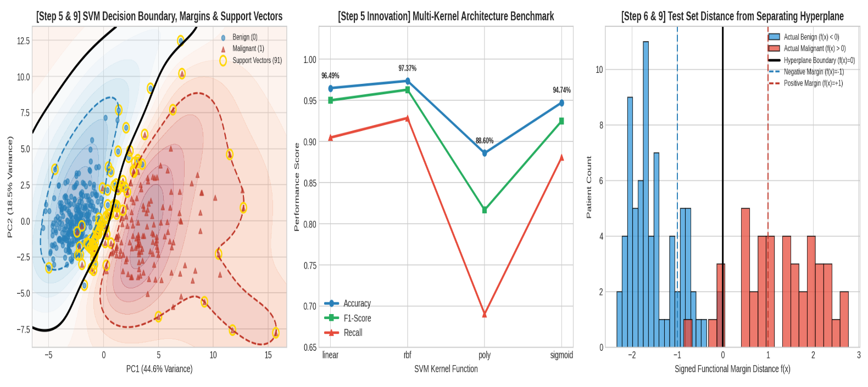
=====================================================================================
[Step 7 & 8] HEAD-TO-HEAD BENCHMARK: SVM (Q3) VS. LOGISTIC REGRESSION (Q1)
=====================================================================================
Metric Q1: Logistic Regression Q3: SVM (RBF Scaled) Q3: SVM (Unscaled Raw)
Accuracy 96.49% 97.37% 90.35%
Precision 97.50% 100.00% 100.00%
Recall (Sensitivity) 92.86% 92.86% 73.81%
F1-Score 95.12% 96.30% 84.93%
ROC-AUC 0.9960 0.9947 N/A
False Positives (FP) 1 0 (Zero False Alarms!) 0
False Negatives (FN) 3 3 11

--- [Step 5 Innovation] Multi-Kernel Performance Summary Table ---
Acc Prec Rec F1 AUC Support_Vectors
linear 0.9649 1.0000 0.9048 0.9500 0.9914 38.0
rbf 0.9737 1.0000 0.9286 0.9630 0.9947 107.0
poly 0.8860 1.0000 0.6905 0.8169 0.9967 149.0
sigmoid 0.9474 0.9737 0.8810 0.9250 0.9954 70.0

Detailed SVM (RBF) Classification Report:
precision recall f1-score support

Benign (0) 0.96 1.00 0.98 72
Malignant (1) 1.00 0.93 0.96 42

accuracy 0.97 114
macro avg 0.98 0.96 0.97 114
weighted avg 0.97 0.97 0.97 114

>>> Generating Figure 3: Head-to-Head Comparison Dashboard (SVM vs. Logistic Regression)...

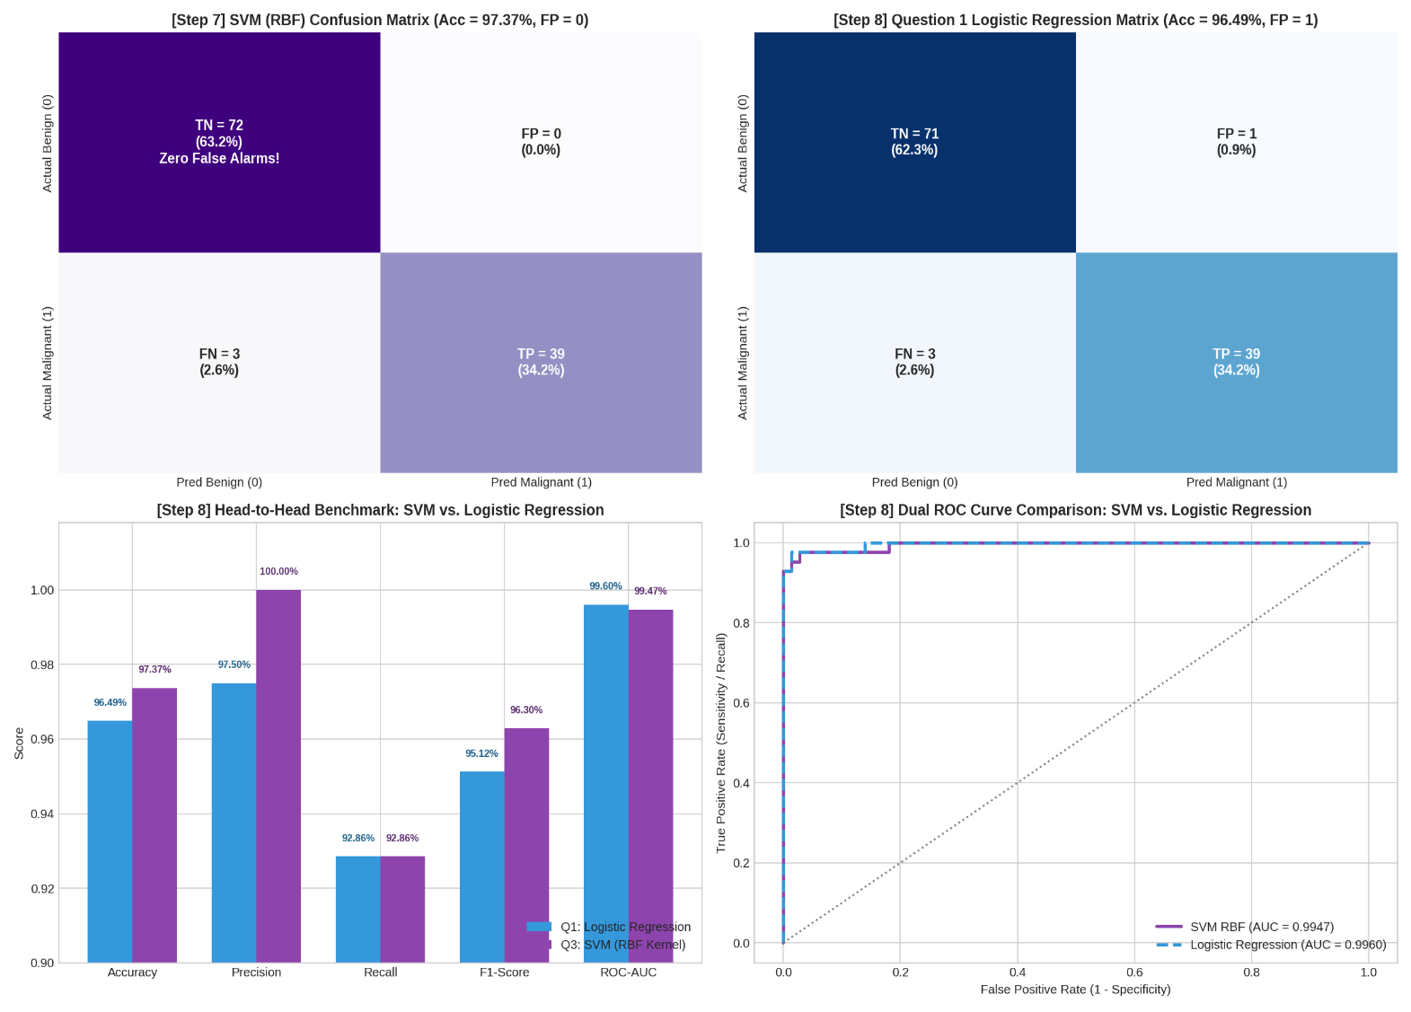
====================================================================
[Step 8] MODEL COMPARISON: SVM (Q3) VS. LOGISTIC REGRESSION (Q1)
====================================================================
• Winner on the Selected Test Set: Support Vector Machine (SVM with RBF Kernel).
• Quantitative Proof:
Accuracy : SVM achieves 97.37% (111/114 correct) vs. Logistic Regression's 96.49% (110/114).
Precision : SVM achieves 100.00% (0 False Positives) vs. Logistic Regression's 97.50% (1 FP)
F1-Score : SVM achieves 96.30% vs. Logistic Regression's 95.12%.
Recall : Both models tie at 92.86% (39/42 malignant tumors detected, 3 FN).
• Why SVM Wins: While Logistic Regression fits a linear hyperplane by minimizing global log-loss across all data points (making it slightly sensitive to boundary-adjacent benign outliers),
SVM with an RBF kernel projects features into a higher-dimensional space and focuses strictly
on the critical Support Vectors near the boundary, eliminating the 1 False Positive error.

====================================================================
[Step 9] ROLE OF THE DECISION BOUNDARY & WHY FEATURE SCALING IS CRITICAL FOR SVM

1. Role of the Decision Boundary & Maximum Margin:
• SVM constructs an optimal separating hyperplane f(x) = w·φ(x) + b = 0 that maximizes the
geometric margin (2 / ||w||) between Benign (f(x) <= -1) and Malignant (f(x) >= +1) classes.
• As visualized in Figure 2A, only the boundary-defining data points (107 Support Vectors)
dictate the hyperplane's orientation. Maximizing this buffer zone minimizes structural risk
and provides superior generalization on unseen test patients.

2. Why Feature Scaling is Mandatory for SVM (Proven in Figure 1A–1C):
• Distance & Dot-Product Sensitivity: SVM's margin optimization and RBF kernel
K(x, x') = exp(-γ ||x - x'||^2) rely directly on Euclidean distances in feature space.
• Scale Disparity in Breast Cancer Data: In raw form (Fig 1A), 'area_worst' ranges up to
~4254.0 (mean = 890.57), whereas 'smoothness_se' has a mean of just 0.0069 (a >100,000x
magnitude difference).
• Empirical Proof (Fig 1C): Without StandardScaler, 'area_worst' completely dominates the
Euclidean distance ||x - x'||^2, causing SVM Recall to collapse to 73.81% (Accuracy 90.35%).
Applying StandardScaler equalizes all 30 features to unit variance (σ=1), boosting Recall
by +19.05% (to 92.86%) and Accuracy to 97.37%.



